Lab 01

1. **Relative to Solaris 10:**

* **What are the six major advantages of Solaris 10 over Solaris 9?**

1. Physical to Virtual (p2V) Migration
2. Migrate hosted to Oracle Solaris Container
3. Zpool autoexpand
4. Triple Parity RAID-Z
5. Split Mirrored Pools
6. Pool Recovery

* **How do you buy Solaris for a PC and what does it cost?**

You can download a free version or you can buy the Media pack starting at $75

* **What platforms does Solaris 10 run on?**

<http://www.oracle.com/webfolder/technetwork/hcl/data/sol/systems/views/nonoracle_systems_all_results.page1.html>

* **Can you use Office 2003 under Solaris 10? If not, what do I do for applications?**

No you can’t, but you can use applications that run on Solaris and support office files like starOffice or OpenOffice.

1. **What is Linux? Who invented it? Why would someone want to use Linux rather than Solaris if they need UNIX support?**

Linux is an open-source version of the UNIX operating system, You would use linux because it’s free and also because is more compatible than Solaris

1. **Why use UNIX for critical servers rather than a Microsoft operating system?**

The main reason would be because Microsoft is way more vulnerable than UNIX

1. **Draw a diagram of the OSI networking model and briefly describe the functions performed at each level. What is ISO? What is CCITT?**

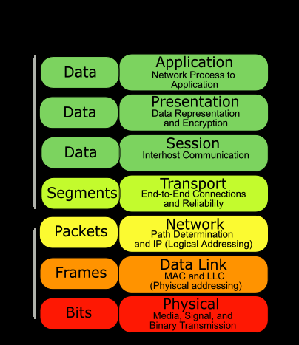

OSI (Open Systems Interconnection) is a standard description or “reference model” for how messages should be transmitted between any two points in a telecommunication network.

CCITT is the Telecommunication Standardization Sector (ITU-T) coordinates standards for telecommunications on behalf of the International Telecommunication Union (ITU) and is based in Geneva, Switzerland.

1. **List the fundamental tasks of a system administrator**

* Install OS
* Configure OS
* Update OS
* Troubleshoot OS
* Support OS